Air Purifiers Market Growth
Google Ads Campaign Strategy for Targeted Reach

The global air purifier market is experiencing rapid growth, driven by increasing awareness about indoor air quality, rising respiratory issues, and urban pollution.
The market size is projected to grow from approximately USD 18 billion in 2025 to over USD 34 billion by 2034, with a steady CAGR around 7%–8%.
Residential and commercial segments both show significant adoption, with technological advancements such as HEPA filters, activated carbon, and UV-C sterilization enhancing product appeal. Regions like Asia-Pacific and North America witness high demand due to pollution concerns and health regulations.

Key Demographic Characteristics:

  - Health-conscious individuals with allergies or respiratory issues
  - Urban populations affected by pollution
  - Families with children and elderly members
  - Tech-savvy consumers interested in smart, app-connected devices
  - Businesses focused on employee well-being and regulatory compliance
  - Geographic focus on Asia-Pacific due to high urbanization and pollution levels, followed by North America and Europe

The Strategy and Online Relevance

Google Ads provides a strategic platform to create targeted air purifier marketing campaigns efficiently.
By building precise keyword lists that reflect high-intent purchase queries (e.g., "air purifier installation," "commercial air filtration solutions"), companies can capture prospects at crucial decision-making moments. Audience segmentation by funnel stage (awareness, consideration, decision) enables tailored ad messaging addressing specific customer needs such as allergy relief or compliance with air quality standards.

Campaigns can prioritize local targeting, retargeting web visitors, and dynamically optimize bids and creatives based on performance data, ensuring every advertising dollar contributes to measurable lead generation and ROI.

Prominent Keywords for Air Purifiers as per AI

- Air purifier
- Best air purifier 2025
- HEPA air purifier
- Air purifier for allergies
- Portable air purifier
- Air purifier for smoke
- Air purifier for home
- Air purifier for pets
- Air purifier filter replacement
- Commercial air purifier
- Air purification system
- Air quality solutions
- Air purifier price
- Smart air purifier
- Air purifier with carbon filter
- Air purifier installation services
Google keywords suggestions – ‘air purifier’:

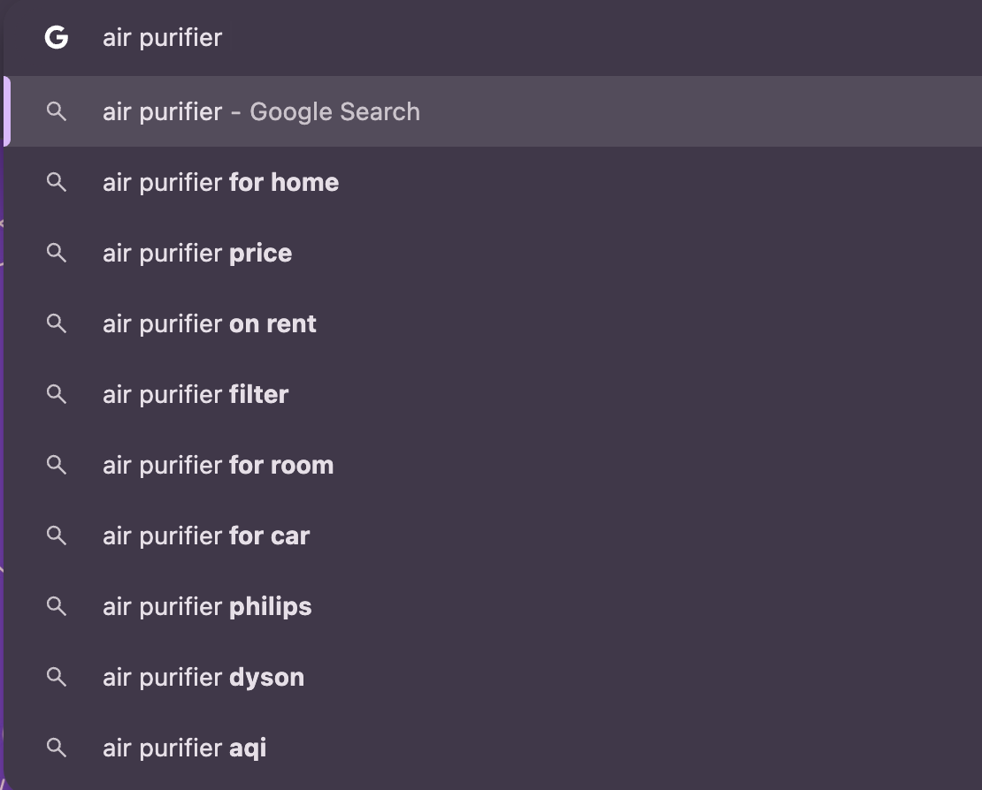

Sponsored results for ‘air purifier’ keyword search:

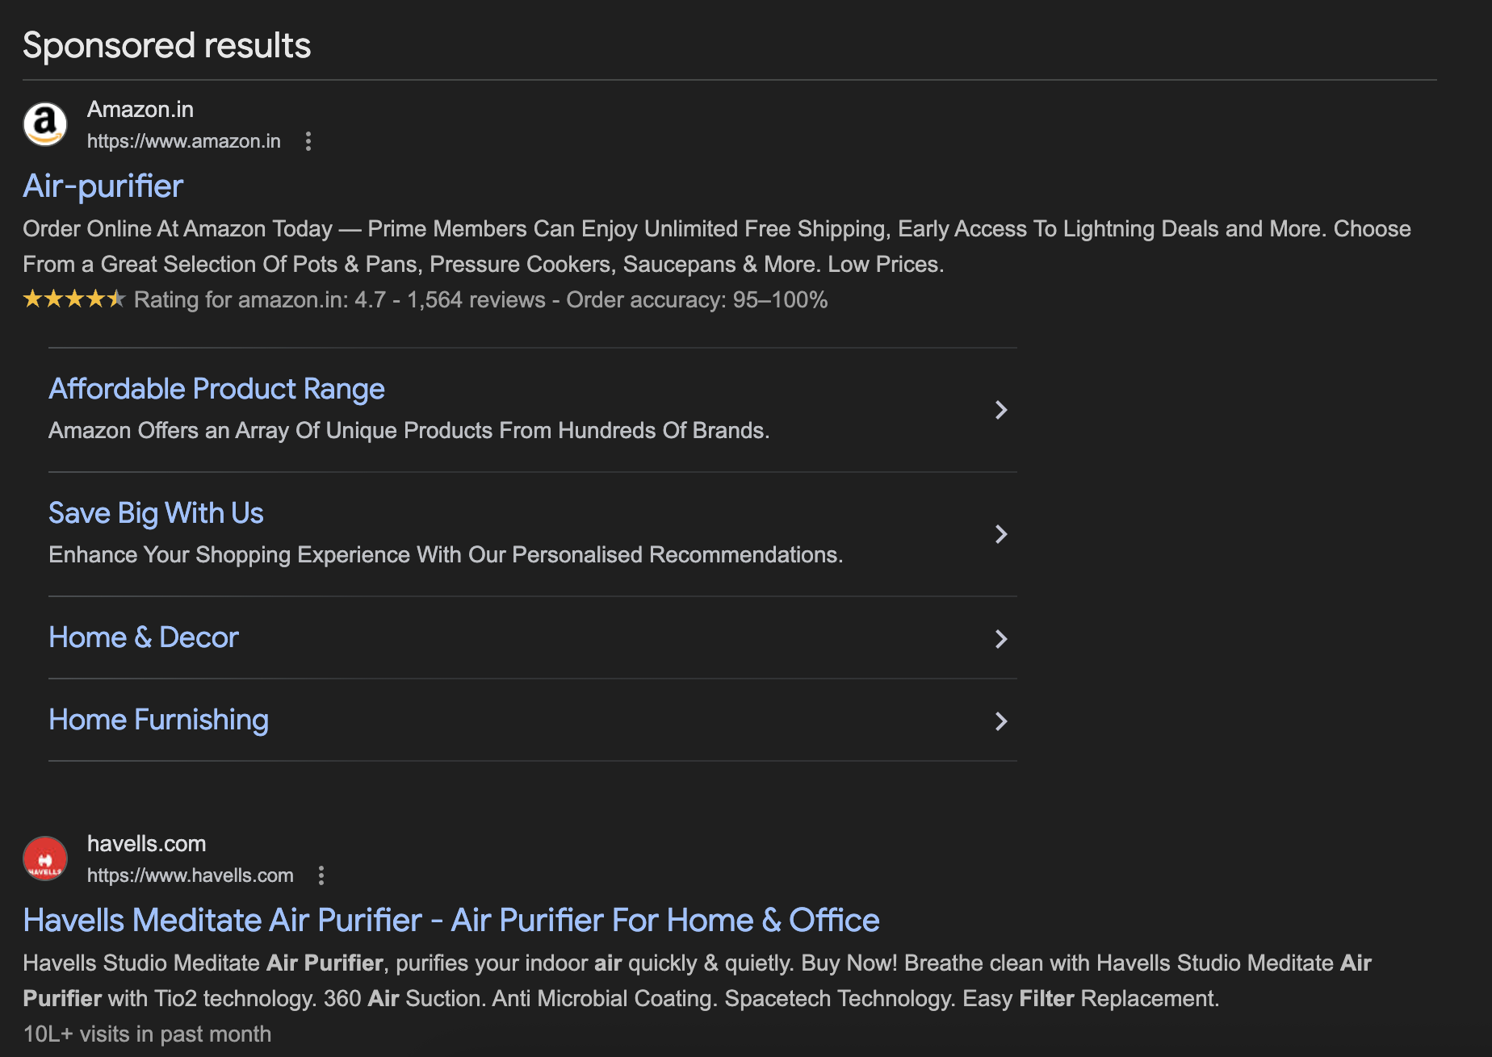
Google keywords suggestions – ‘best air purifier’:

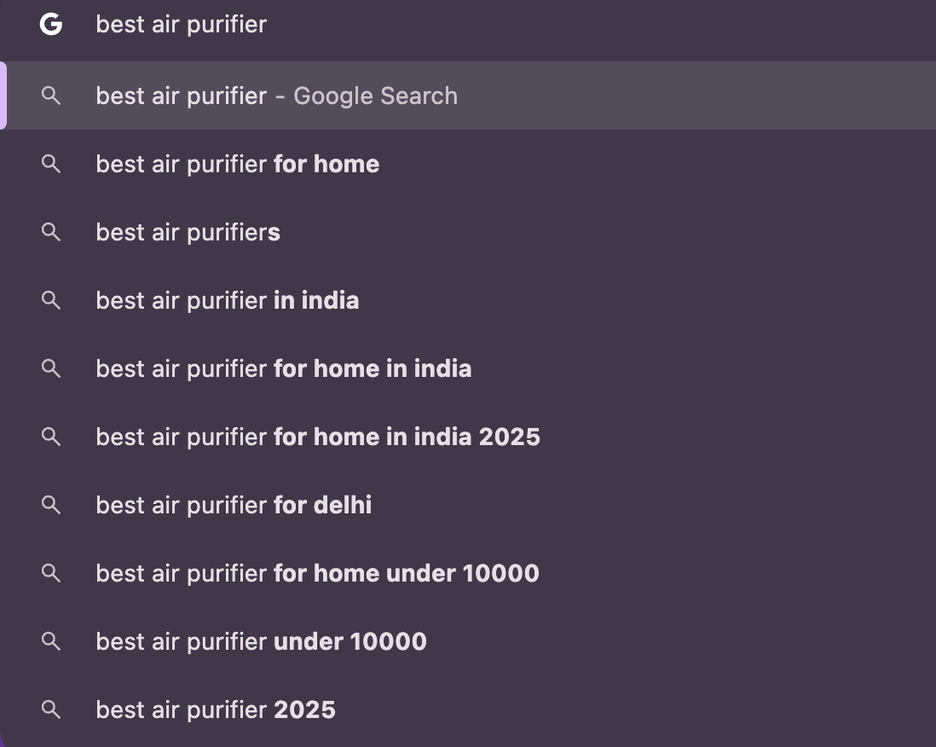

Sponsored results for ‘best air purifier’ keyword search:

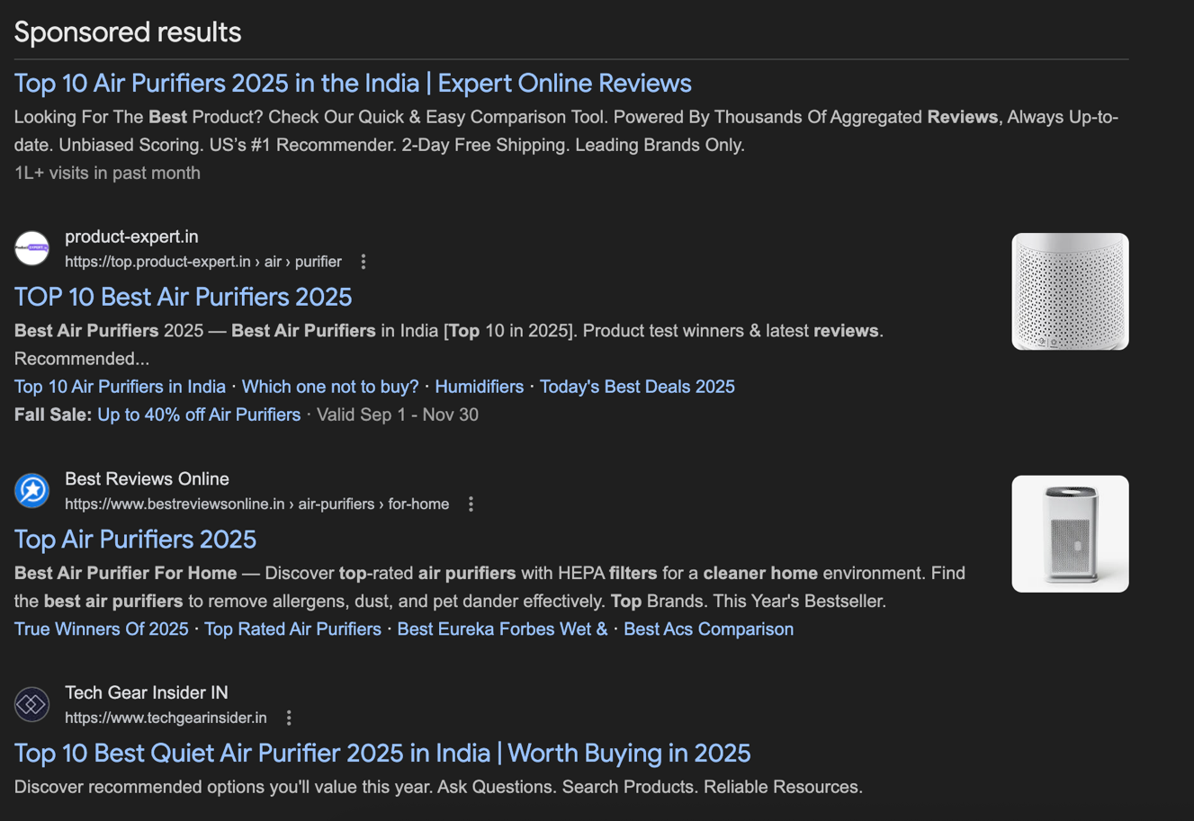
Call to Action

CTA example from AI:

This CTA is action-oriented ("Buy Now"), emphasizes a clear benefit ("Cleaner Air"), and includes an incentive ("Free Shipping") to encourage immediate purchases. Other strong CTAs for this category could be:
- "Shop the Best Air Purifiers Today – Breathe Healthier Tomorrow"
- "Get Your Air Purifier Installed Fast – Order Online"
- "Protect Your Family from Allergens – Buy Air Purifiers Now"
- "Improve Indoor Air Quality – Start with a Discounted Purifier"

Real examples from google:

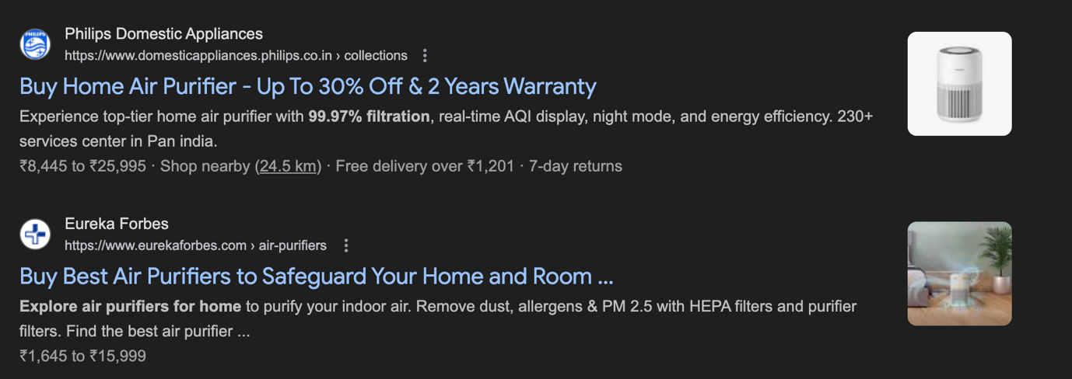
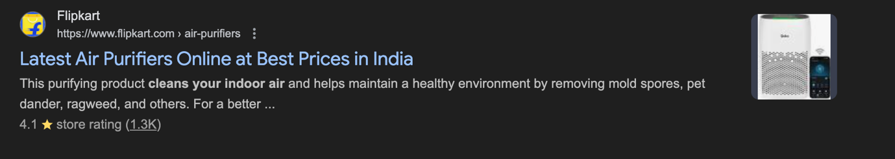
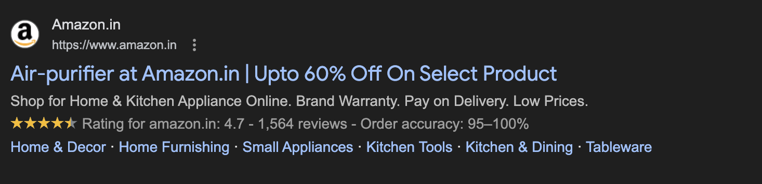
URL : www.havells.airpurifiers.com

